**RMIT University**

**The total weighted mark for this final test is 20%.**

**AERO2380 Assessment 4 – Individual Take Home Assignment**

**(An essay of approximately 750-1000 words is expected, but there is no fixed upper limit.)**

**ANSWER SHEET**

**Minidu Ilangakoon**

**s4076820**

An Australian domestic airline is failing to attract sufficient passenger numbers to achieve the growth required by its business plan. The airline has hired you as a Quality Consultant to help it implement a quality improvement initiative and hence revive the business.

With reference to ***any three*** of the seven fundamental principles of quality management outlined in ISO9001:2015, supported by any applicable Basic Quality Tools and/or Quality Improvement methodologies, suggest practical ways in which the airline might improve its business prospects. (Approximately 250-350 words per principle is expected).

**Reviving an Australian Domestic Airline through ISO 9001:2015 Quality Principles**

An Australian domestic airline facing weak passenger demand can use ISO 9001:2015 to rebuild reliability, trust, and preference. This report applies three principles—Customer Focus, Process Approach, and Improvement—anchored by Basic Quality Tools (Check Sheets, Pareto, Cause-and-Effect, Control Charts, Histograms, Scatter, Flowcharts) and proven methodologies (QFD, Kano, PDCA, DMAIC, VSM, 5S, Poka‑Yoke, FMEA, A3). The objective is to convert quality into visible market outcomes: higher on-time performance (OTP), reduced mishandled baggage, smoother journeys, credible communication, and repeat patronage across major stations (SYD, MEL, BNE, PER, ADL).

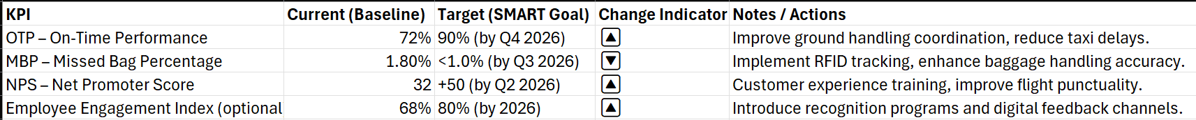

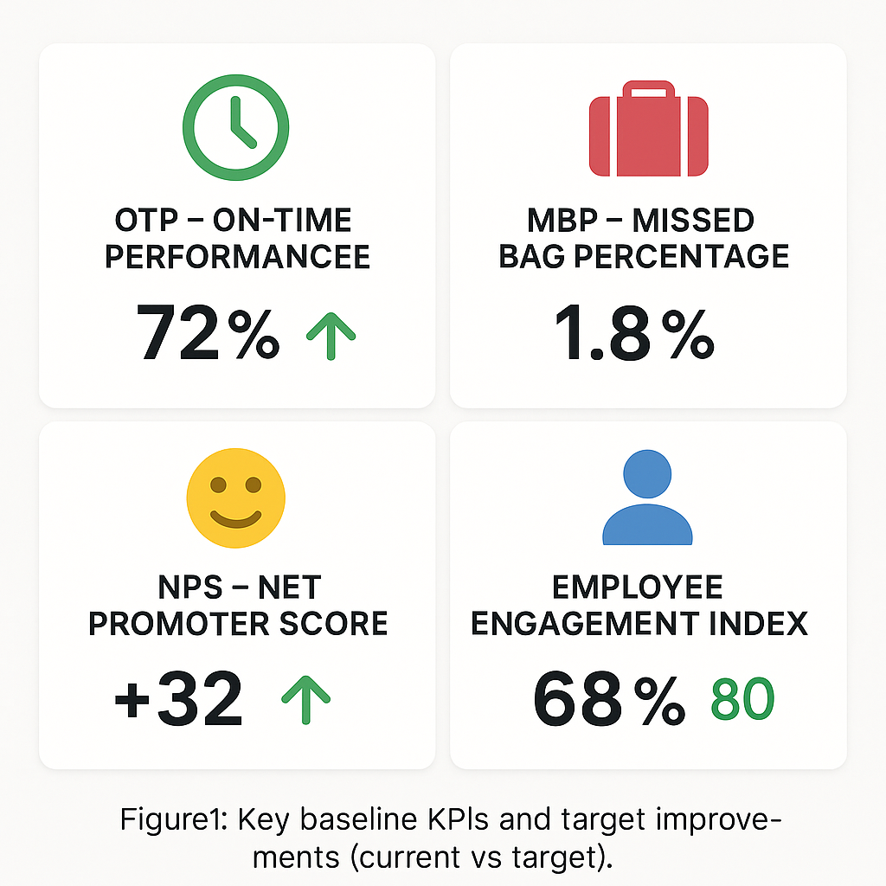

*Figure 1: Key baseline KPIs and target improvements (current vs target)*

**1) Customer Focus (ISO 9001:2015 Principle 1)**

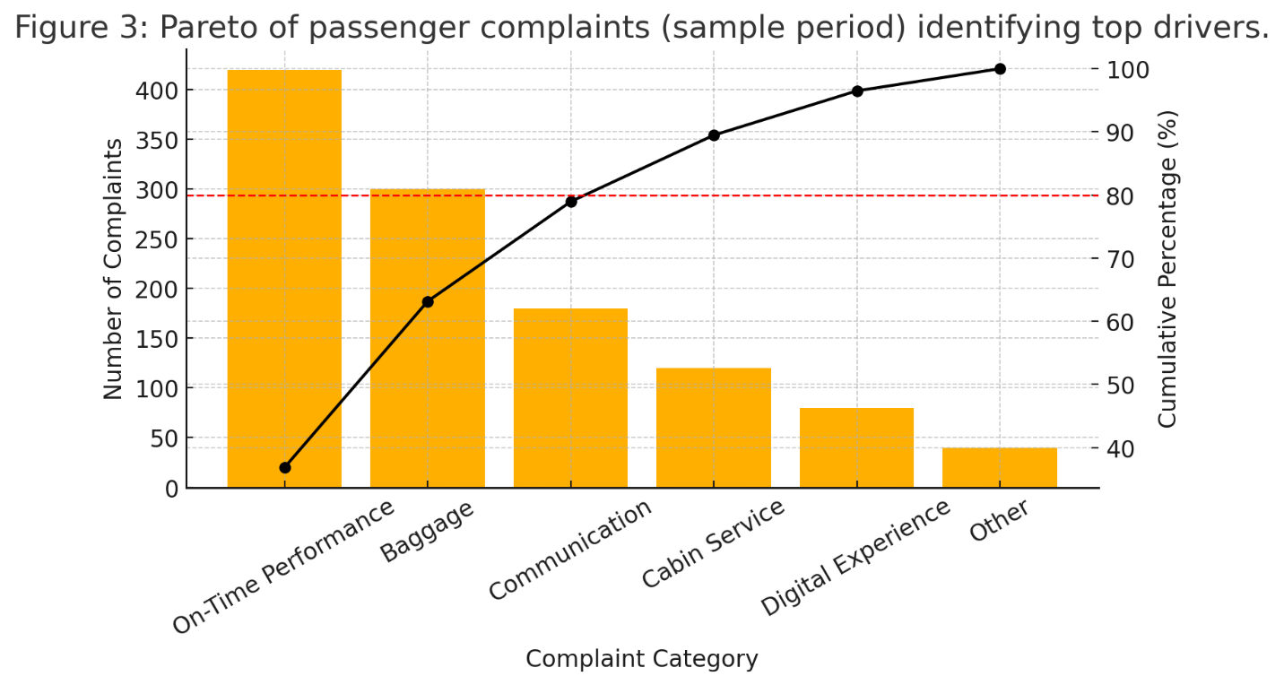Establish a rigorous Voice of the Customer (VoC) system involving the entire journey—fare search, booking, check-in/bag-drop, boarding, in-flight, arrival, baggage reclaims, and disruption recovery. Use post-flight CSAT/NPS/CES, call/chat logs, social listening, app-store reviews, and complaint data. Frontline staff capture defects via simple Check Sheets (e.g., inaudible gate announcements, unpredictable cabin cleanliness, last-bag-to-belt > 20 min). Prioritize with Pareto Charts to isolate the “vital few” dissatisfaction drivers—typically punctuality, baggage reliability, and disruption information.

Translate customer priorities into operational CTQs with Quality Function Deployment (QFD): - Reliable departures → D0 pushback readiness, D15 OTP, gate readiness by T–45, crew sign-on compliance. - Digital ease → three-click change/cancel, transparent ancillary pricing, <2 s app loads. - Baggage confidence → ≥99.5% scan compliance, ≥99.8% tag readability, real-time alerts for unscanned transfers.

Use Kano Analysis to distinguish must-be basics (cleanliness, accurate seat maps) from performance attributes (OTP) and delighters (proactive rebooking with seat preservation). Service blueprinting reveals friction such as gate crowding or mismatched boarding zones to stowage patterns.

Practical quick wins: - Proactive disruption comms: Push specific delay reasons and accurate ETDs via app/SMS; one-tap rebooking for >60-minute delays; automatic meal/e-credit rules above set thresholds. - Baggage confidence: Poka-Yoke tag printing and mandatory scan gates; instant e-vouchers for delayed bags; station-level DMAIC on mishandling codes. - Cabin consistency: Standardized cleaning checklists, 5S galley layouts, random audits, and SPC control charts for pass/fail rates.

Key measures: NPS/CSAT by journey stage, complaint rate per 10k pax, “ready-to-fly” check completion, D0/D15, mishandled bags per 1,000 pax (MBP), last-bag-to-belt

**2) Process Approach (ISO 9001:2015 Principle 4)**

|  |  |  |
| --- | --- | --- |
| **Element** | **Description** | **CTQs (Critical to Quality)** |
| **Suppliers** | - Ground handling agents  - Fuel suppliers  - Catering providers  - Cabin cleaning contractors  - Air Traffic Control (ATC)  - Maintenance teams | - Timely service provision  - Resource availability |
| **Inputs** | - Flight schedule & gate assignment  - Fuel truck, catering truck, and cleaning crew  - Passenger and baggage manifests  - Equipment (GPU, air stairs, tugs) | - Accuracy of data  - Availability of ground equipment |
| **Process (Turnaround)** | 1. Aircraft arrival and choking  2. Passenger disembarkation  3. Baggage offloading  4. Cabin cleaning and catering replenishment  5. Refueling and technical checks  6. Boarding preparation  7. Passenger boarding  8. Final checks and pushback clearance | - Coordination efficiency  - Safety compliance  - Minimum ground time (Target: < 35 min) |
| **Outputs** | - Ready-for-departure aircraft  - Updated flight documentation  - Passenger and baggage loaded  - Safety and security cleared | - On-time departure (OTP target ≥ 90%)  - Zero safety deviations |
| **Customers** | - Passengers- Flight crew  - Airline operations control  - Airport authority  - Ground handling management | - Customer satisfaction (NPS ≥ +50)  - Punctuality and reliability |

*Figure 4: SIPOC for aircraft turnaround at major stations.*

Reliability emerges from interconnected processes across airline, airport, and suppliers. Start with SIPOC and end-to-end process maps for core flows: booking/ticketing, airport departure, flight operations, arrival/baggage, and customer recovery. At major stations, apply Value Stream Mapping (VSM) to expose queues, handoff delays, and rework, especially during aircraft turns.

Standardize the “critical few” processes that drive schedule integrity:

* Turnaround: Timestamped standard work across ramp, cleaning, catering, fueling, and crew; visual gate boards showing plan-vs-actual milestones; short daily stand-ups to review misses and countermeasures. Protect first-wave departures with modest buffers to dampen network knock-on delays.
* Boarding: Zone design based on seat rows and carry-on volumes; consistent carry-on sizer enforcement; “ready-to-fly” lanes for pre-validated passengers; clear scripts and gate signage. Use Histograms to analyze boarding time distributions and reduce variance.
* Baggage: Mandatory scanning choke points, tag readability checks, and real-time alerts for unscanned transfers; Pareto analysis by mishandling code (e.g., failure to load, transfer miss) to focus corrective actions.

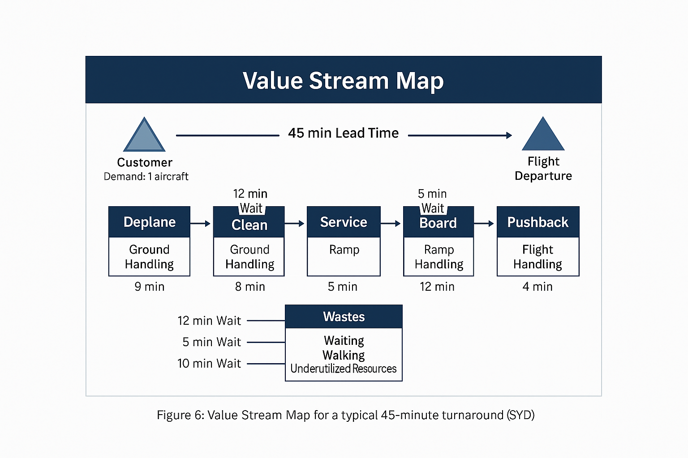Root-cause rigor: apply Ishikawa (Cause-and-Effect) diagrams on chronic delay categories (crew, catering, late inbound, maintenance, gate availability), then 5 Whys to isolate causes. Stratify by station, aircraft type, daypart, and crew base to detect non-random variation. Use flowcharts to clarify role handoffs; align SLAs with ground handlers and caterers to the same process KPIs and escalation paths.

Assign process owners and KPIs: - Departure: D0, D15, controllable delay minutes per flight, average taxi-out. - Boarding: Mean/variance of boarding time, gate hold minutes, carry-on

*Figure 5: Value Stream Map for a typical 45-minute turnaround (SYD)*

overage rate. - Baggage: MBP, scan compliance %, last-bag-to-belt time.

Use SPC control charts to detect special-cause variation and trigger rapid containment and corrective action. Codify changes into SOPs and training; conduct monthly audits and quarterly reviews to sustain gains.

**3) Improvement (ISO 9001:2015 Principle 5)**

Institutionalize continuous improvement using PDCA for fast experiments and DMAIC for complex, chronic problems. Maintain a pipeline of A3 projects tied to revenue-critical outcomes: fewer cancellations, faster turns, better disruption recovery, higher digital conversion, and loyalty growth.

* PDCA sprints: Pilot a revised boarding script at SYD/MEL for two weeks (Plan), train and implement (Do), compare boarding-time means/variance vs matched control gates (Check), and standardize or refine (Act). Document lessons, update SOPs, and roll out with micro‑learning modules.
* DMAIC exemplar—reduce MBP by 40% in six months: Define CTQs (scan compliance, transfer integrity), Measure baseline by station/route, analyze with fishbones and regression to identify drivers (peak-hour transfers, staffing profiles), Improve via mandatory scan gates and transfer buffers, Control with SPC and weekly station huddles.

Engage staff and suppliers: - Simple suggestion system with Check Sheets; Pareto to priorities ideas; recognition for ideas that cut delay minutes or raise CSAT. - Daily SQDCP (Safety, Quality, Delivery, Cost, People) huddles at gates/ramps to visualize performance and actions. - Gemba walks by leaders to reinforce standards and surface issues in real time.

*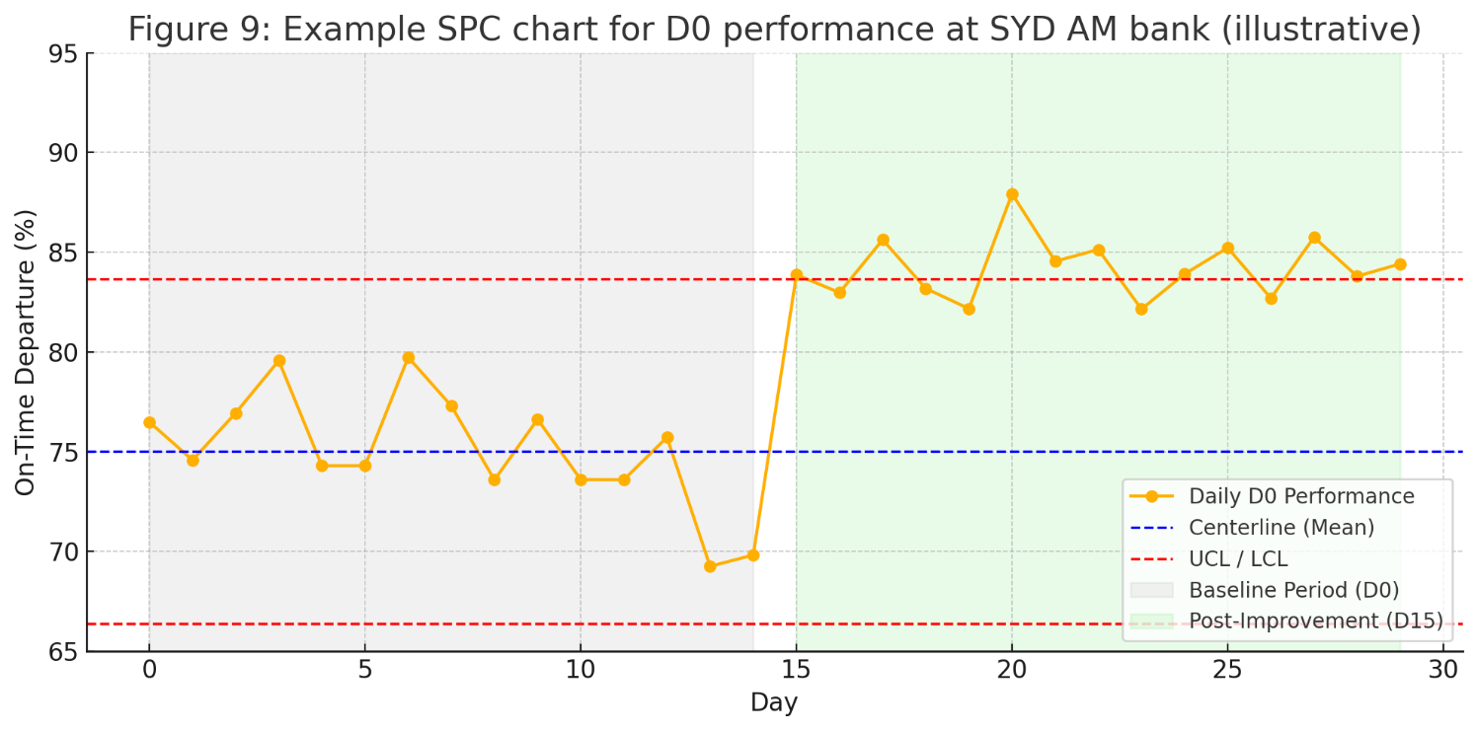Figure 6: Example SPC chart for D0 performance at SYD AM bank (illustrative).*

Evidence-based decisions and risk-based thinking:

- Link operational metrics (OTP, MBP, cancellations) to commercial outcomes (load factor, route share, compensation cost, lifetime value). Quantify Cost of Poor Quality (reaccommodation, hotels/meals, missed connections, lost loyalty).

- Use Scatter plots/regressions to identify leverage (e.g., each 1 pp D0 improvement in morning bank correlates with fewer same-day cancellations).

- Apply FMEA to turns and disruption recovery; prioritize high-RPN failure modes (late catering deliveries, gate equipment conflicts, DCS outages) and implement mitigations (alternate load plans, backup gate rules, offline boarding procedures).

Governance and transparency: - Quarterly management reviews of CTQs, audit results, and customer outcomes.

- Publicly share reliability stats and customer-facing enhancements to rebuild brand credibility in the domestic market.

**Conclusion**

By aligning to customer-defined value, stabilizing interdependent operational processes, and embedding a disciplined improvement engine, the airline can convert quality into competitive advantage. Better OTP, fewer baggage issues, and credible, proactive communication directly influence customer choice and repeat purchase in Australia’s domestic market. Executed with basic quality tools and proven methods (QFD, Kano, PDCA/DMAIC, VSM, SPC, FMEA), this plan improves load factors, reduces avoidable costs, and places the airline on a sustainable growth trajectory.

**Selected References**

* ISO (2015). ISO 9001:2015 Quality Management Systems—Requirements.
* Deming, W. E. (1986). Out of the Crisis. MIT Press.
* Montgomery, D. C. (2019). Introduction to Statistical Quality Control (8th ed.). Wiley.
* Akao, Y. (1990). Quality Function Deployment. Productivity Press.
* Kano, N. et al. (1984). Attractive quality and must-be quality. Journal of the Japanese Society for Quality Control.
* Womack, J. P., & Jones, D. T. (1996). Lean Thinking. Simon & Schuster.
* IATA (2012). Baggage Improvement Program: Best Practices.
* BITRE (Commonwealth of Australia). On-time performance of domestic airlines (monthly series).